

**DTBM Furniture**

|  |  |  |
| --- | --- | --- |
| **Supervisor:** | *LÊ THANH NHÂN* | |
| **Semester:** | *II* | |
| **Batch No:** | *T1.2112.E0* | |
| **Group No:** | *III* | |
| **Order:** | **Full name** | **Roll No.** |
| *1.* | *Phạm Anh Đoàn* | *Student1345184* |
| *2.* | *Khương Xuân Thanh* | *Student1342864* |
| *3.* | *Phan Như Bảo* | *Student1350320* |
| *4.* | *Trần Nhật Minh* | *Student1357832* |

***Month****: October* ***Year****:2022*



This is to certify that

|  |  |
| --- | --- |
| **Mr.** | **Phạm Anh Đoàn** |
| **Mr.** | **Khương Xuân Thanh** |
| **Mr.** | **Phan Như Bảo** |
| **Mr.** | **Trần Nhật Minh** |

Have successfully Designed & Developed

|  |  |  |
| --- | --- | --- |
|  |  |  |
| **DTBM FURNITURE** | | |

Submitted by:

|  |
| --- |
| **Mr. LE THANH NHAN** |

Date Of Issue:

|  |  |
| --- | --- |
|  |  |

Authorized Signature:

|  |  |
| --- | --- |
|  |  |
| **Content** | | | |

Content

Acknowledge

Synposis

Review1 (01-05)

Review2 (07-17)

Review3 (19-30)

Testting Document (31)

Final Checklist (32)

Tasksheet (33)

|  |
| --- |
| **Acknowledge** |

As we understand that the important project helps us to build a lot of experiences

such as:

* Practice step by step i.e. laddered approach.
* Build a large more robust application.
* Learn the implementation of concepts in a phased manner.
* Enhance skills such as teamwork, time schedule, time planning, and guarantee

finishing tasks to be given.

* Work on real-life projects.
* Give a real-life scenario and help to create applications more complicated and

useful.

* Mentoring through email support.

furthermore, we would like to say deep thanks to Mr. Le Thanh Nhan for his

support during the process of our DTBM Furniture project.

Especially, we also thank you so much for helping us get more realistic experiences in

this project. We will not stop learning anything as much as we can to be more

successful, and we hope, we will have an opportunity to approach large technology

corporate in nearly the future.

Sincerely,

Team Group 3.

|  |
| --- |
| **Synposis** |

The sample project to work on for real-life projects. These applications will help us to build a larger application in the future.

The sample project will teach us about the front-end and back-end technology the application programs are operating. Besides that, we are provided a real-life scenario that helps us create a basic application and also helps us to have a view more deeply technology industry for preparing the skills and experiences the most suitable before graduating.

**Review 01**

|  |
| --- |
| **Problem Definition** |

The interior is an integral part of our home. So almost every home is fitted with the interior to add points in their home. More than a dozen years ago to buy furniture for the house, people had to move to the location of the interior to buy. Now with the development of human technology can be purchased easily without the need for a selling point. We just need a computer or electricity to be able to earn the interior we need.

Nowadays people like comfort and fast, so to grasp the comfort and quickness of our people we build the Furniture project to buy and sell furniture. Buy furniture on your device. In addition, guests and members can comment to make the quality better.

Determine the problem

* Provide product information to customers and members
* Provide information on the production place related to the product
* Granting for membership management capabilities
* opinions to increase product quality
* Provides the ability to update product information quickly and accurately
* Guest
* Can add products to remove products in the cart
* Ability to register members
* Have suggestions for governance

|  |
| --- |
| **Customer Requirements Specifications** |

Describe the points in the data processing cycle for each user object.

**User:**

**input:**

- Member registration information.

- View product’s information.

- Order selected products.

- Feedback about products

**Process:**

- Search products from database by categories, by product types.

- Process customer registration information.

- Process product’s feedback.

- Process customer orders.

**Output:**

- Notification of successful registration / failure.

- Product information.

- Notification of successful making order order.

- Notifications of successful feedback

**Webmaster:**

**Input:**

- Administrator login information .

- User account information to add/ edit /dilete.

- Category information to add/ edit/ delete.

- Product and Product’s image information to add/ edit/ delete/ search.

- Order information to be search/ approve.

- Customer information to search/ delete.

- Employee information to search/ add/ edit/ delete.

- About information to add/ edit/ delete.

- Contact information to add/ edit/ delete.

- Feedback information to search/ delete.

**Process:**

- Add / edit / search / delete products and product’s image.

- Search/deletnformation of all customer.

- Search all orders and feedback.

- Add / edit / delete search employee .

- Add / edit / delete about and contact, category.

- Update order status.

**Output:**

- Notification to create / update / delete / search category, products, about, contact, employee success / failure.

- Notification to change member account’s status.

- Notification to update order’s status.

**Hardware / software requirement**

|  |  |  |
| --- | --- | --- |
| **Sr.** | **Item** | **Description** |
| 1. | Operating system | Windows 7, 8, or higher |
| 2. | Hardware | CPU Cores or better with 2 Gigabytes of RAM or better |
| 3. | Web Browser | Version in later of: Edge, Firefox, Chrome, etc... |
| 4. | Fonts | Standard font Unicode: Arial, Tahoma, Lucida Console, Times New Roman, etc... |

**Review 02**

|  |
| --- |
| **Data Flow Diagram** |

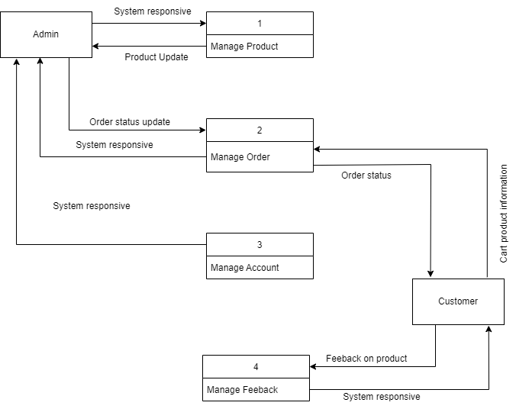

|  |
| --- |
| **A. Entity Relationship Diagram** |

1. **ERD**

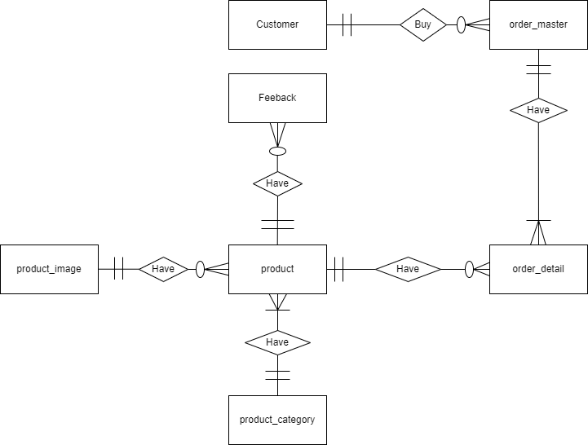

|  |
| --- |
| **B. Entity Attributes** |

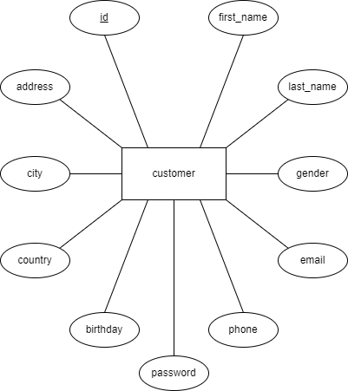

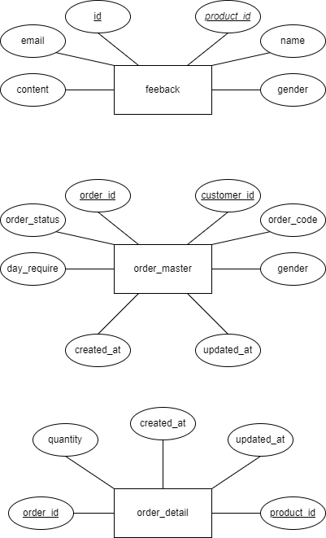

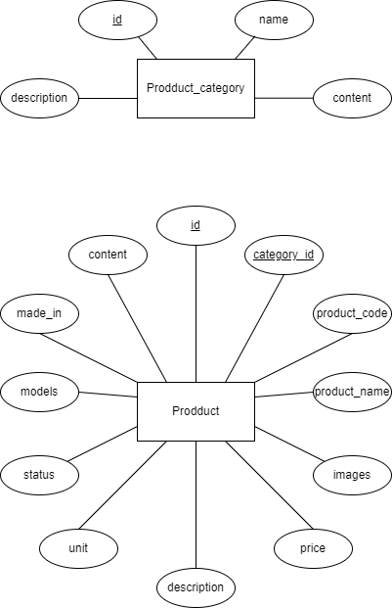

|  |
| --- |
| **A. Table Design** |

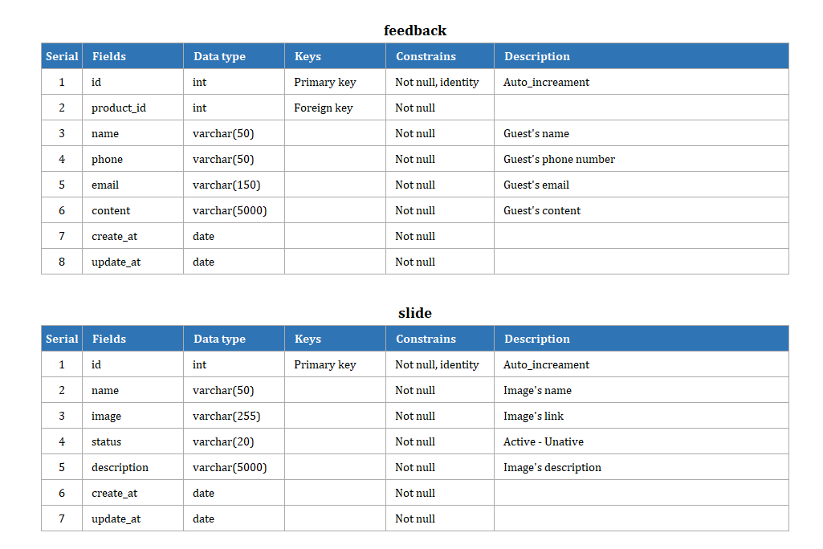

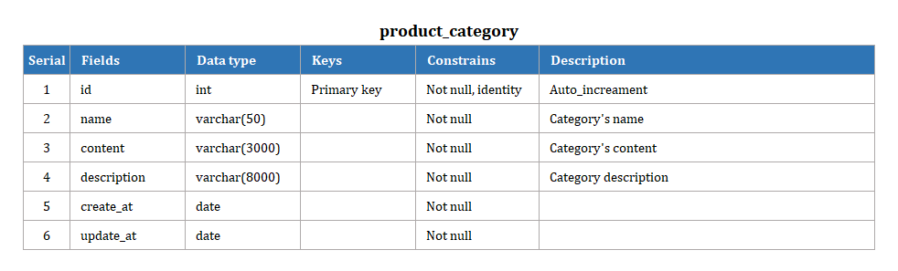

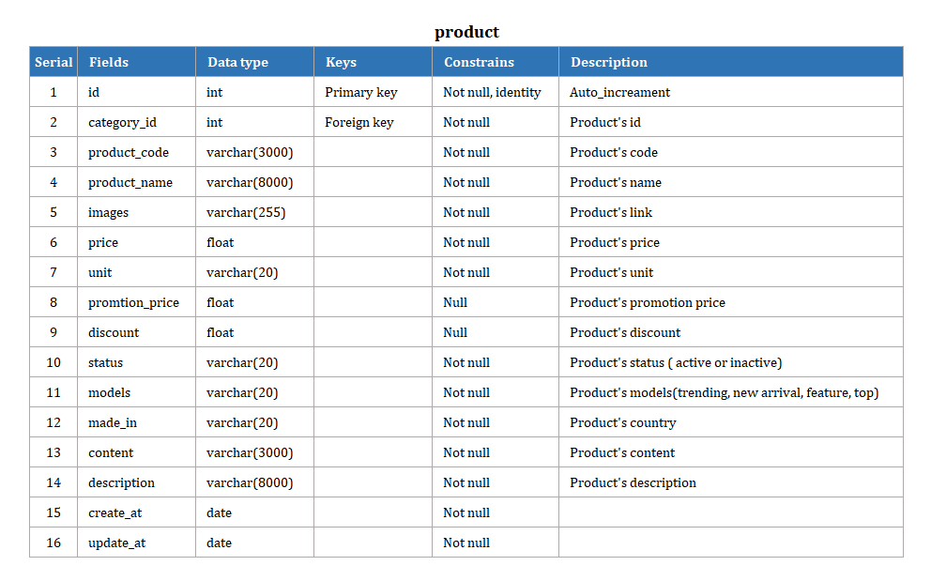

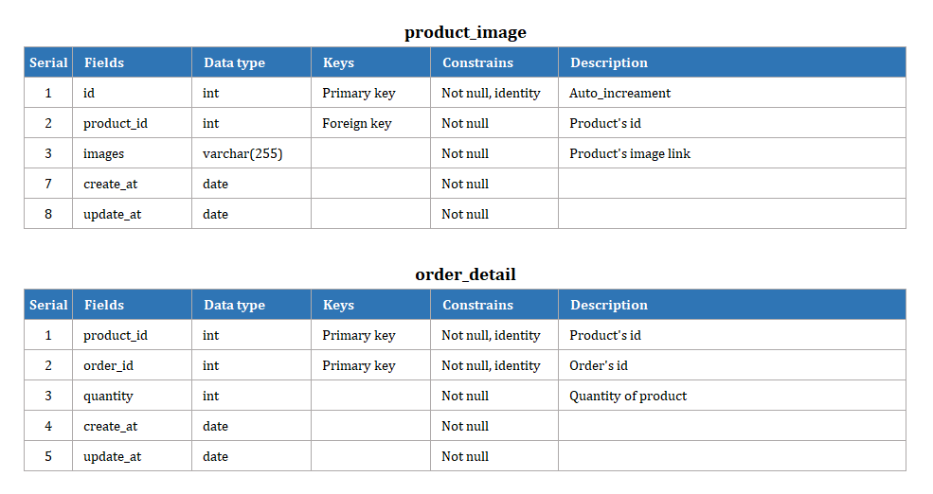

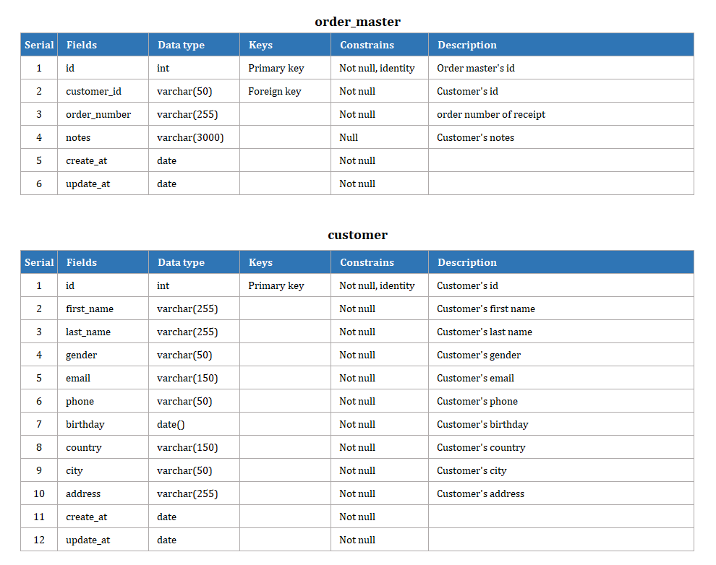

|  |
| --- |
| **B. Relationship Diagram** |

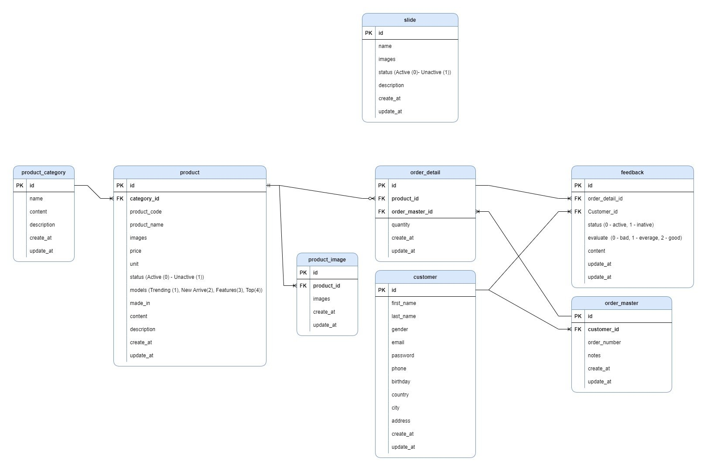

|  |
| --- |
| **SiteMap** |

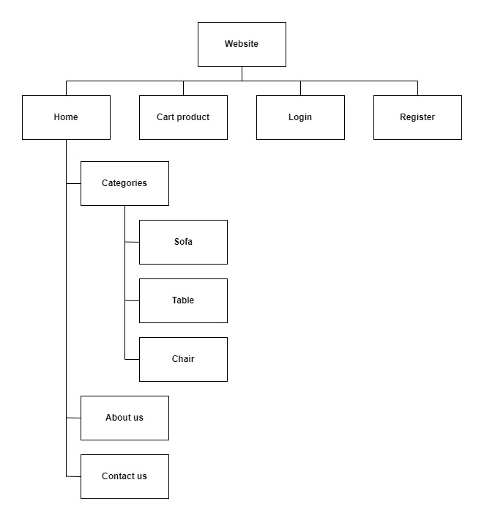

|  |
| --- |
| **Algorithm** |

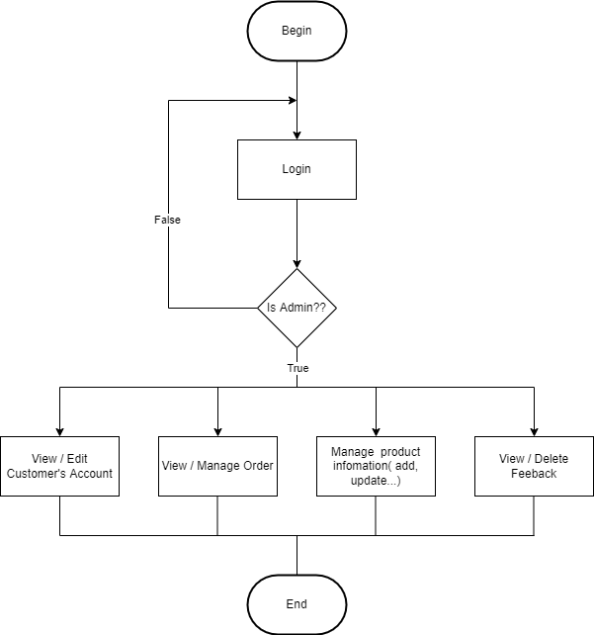

**Review 03**

|  |
| --- |
| **Screen shots** |

1. **Login Form:**

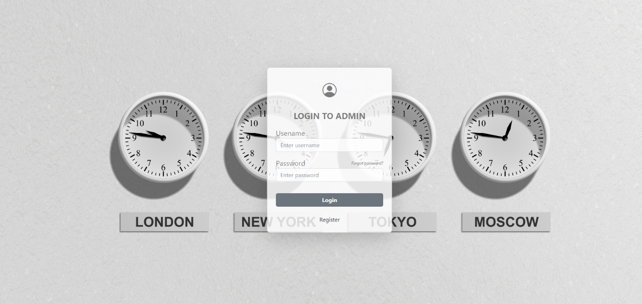

**Description** : Dùng để đăng nhập vào trang quản trị

**From** : <http://127.0.0.1:8000/Admin> (Đường link để vào trang login)

**To** : Chuyển sang trang quản trị DashBoard

1. **Dashboard:**

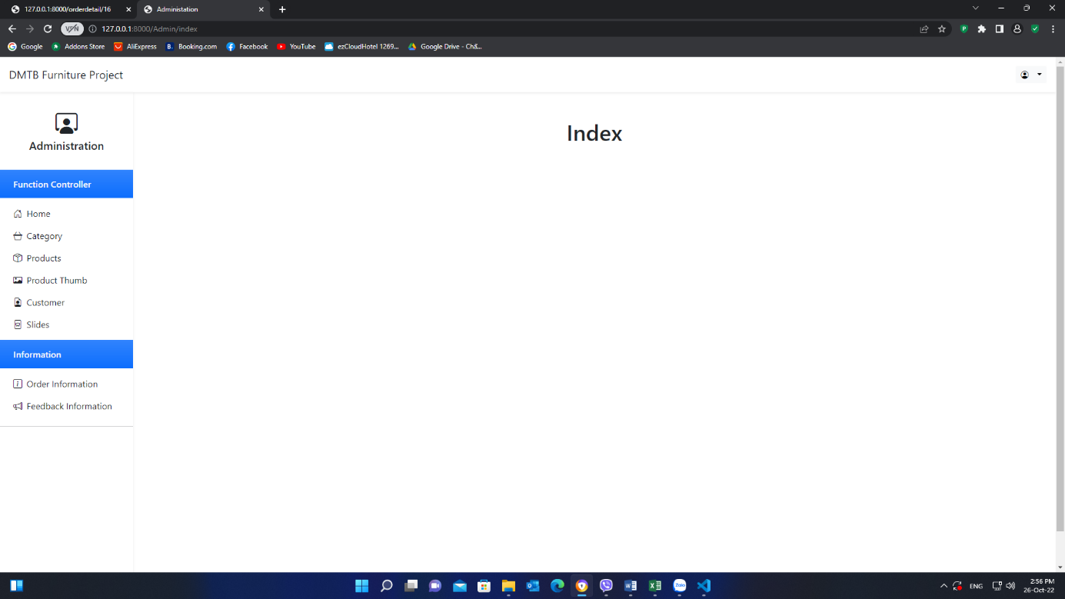

1. **Category Create Page:**

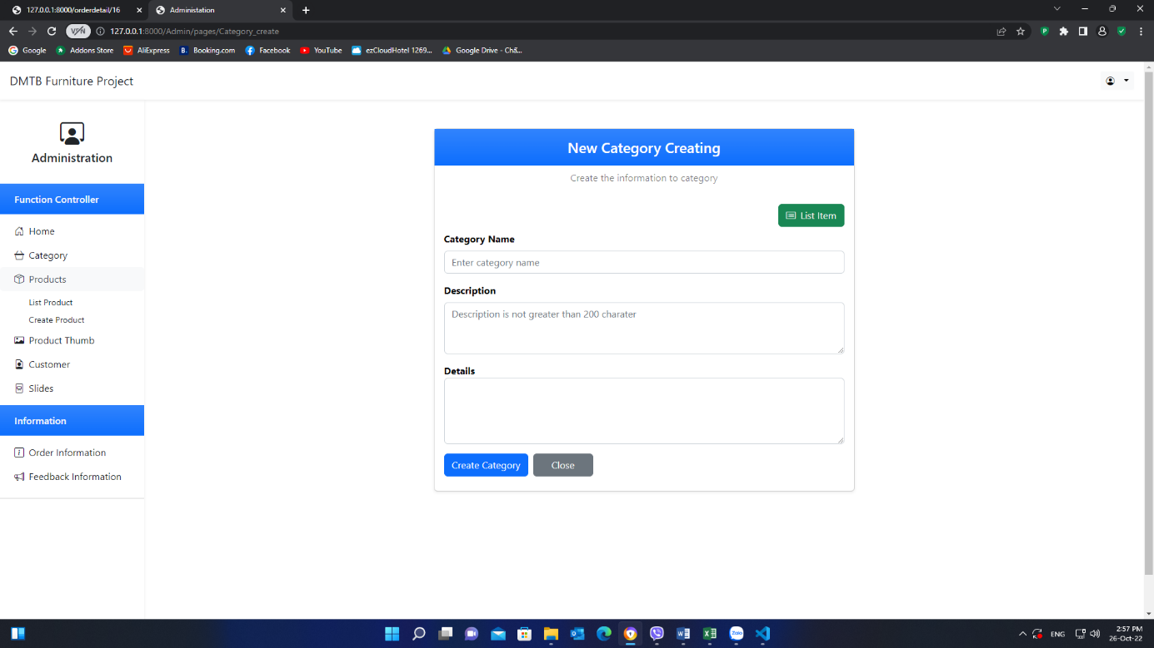

1. **Category List Page**

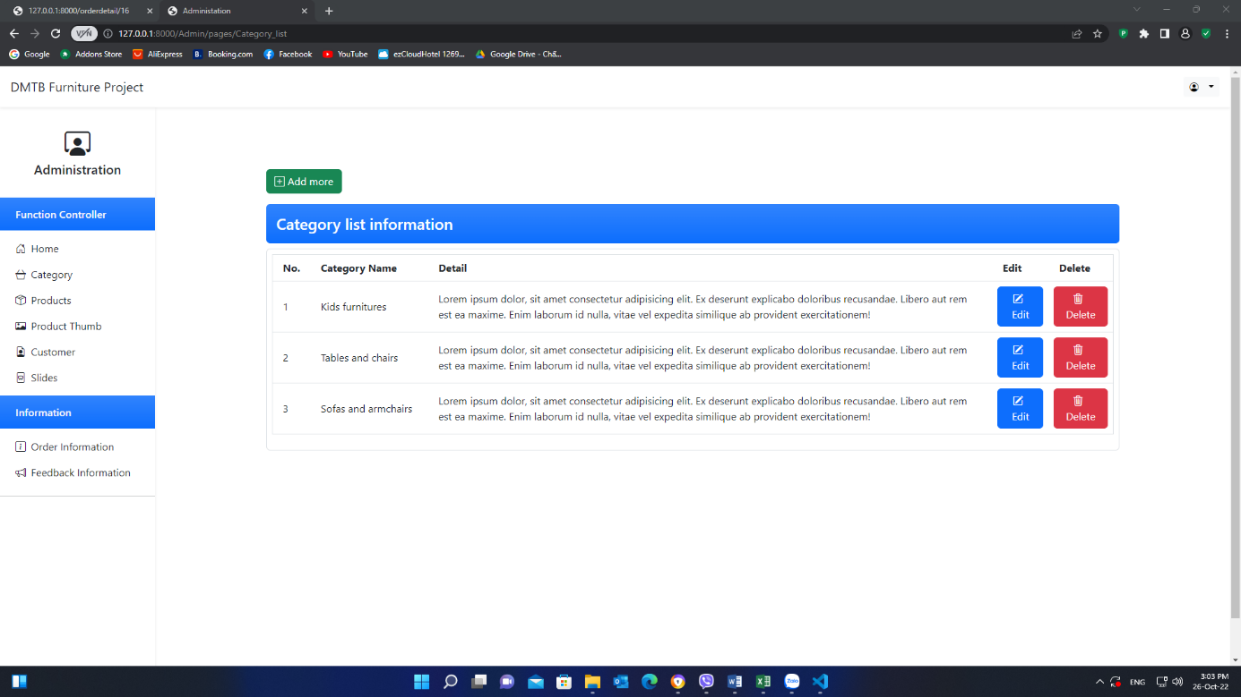

1. **Category Update Page**

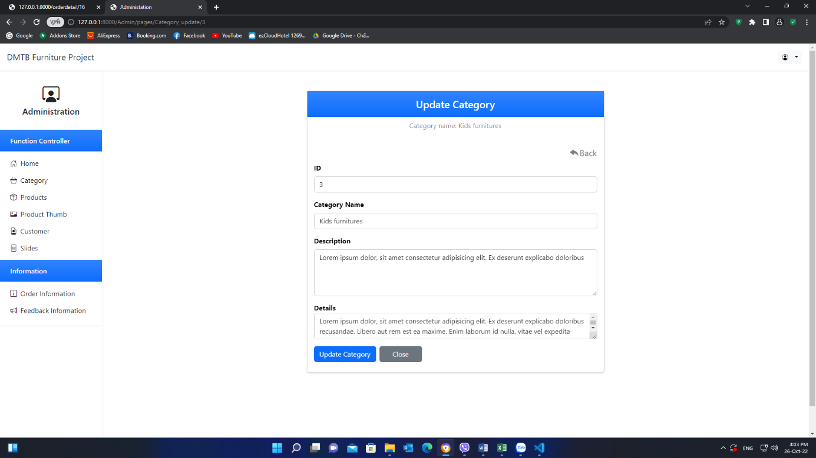

1. **Product Create Page**

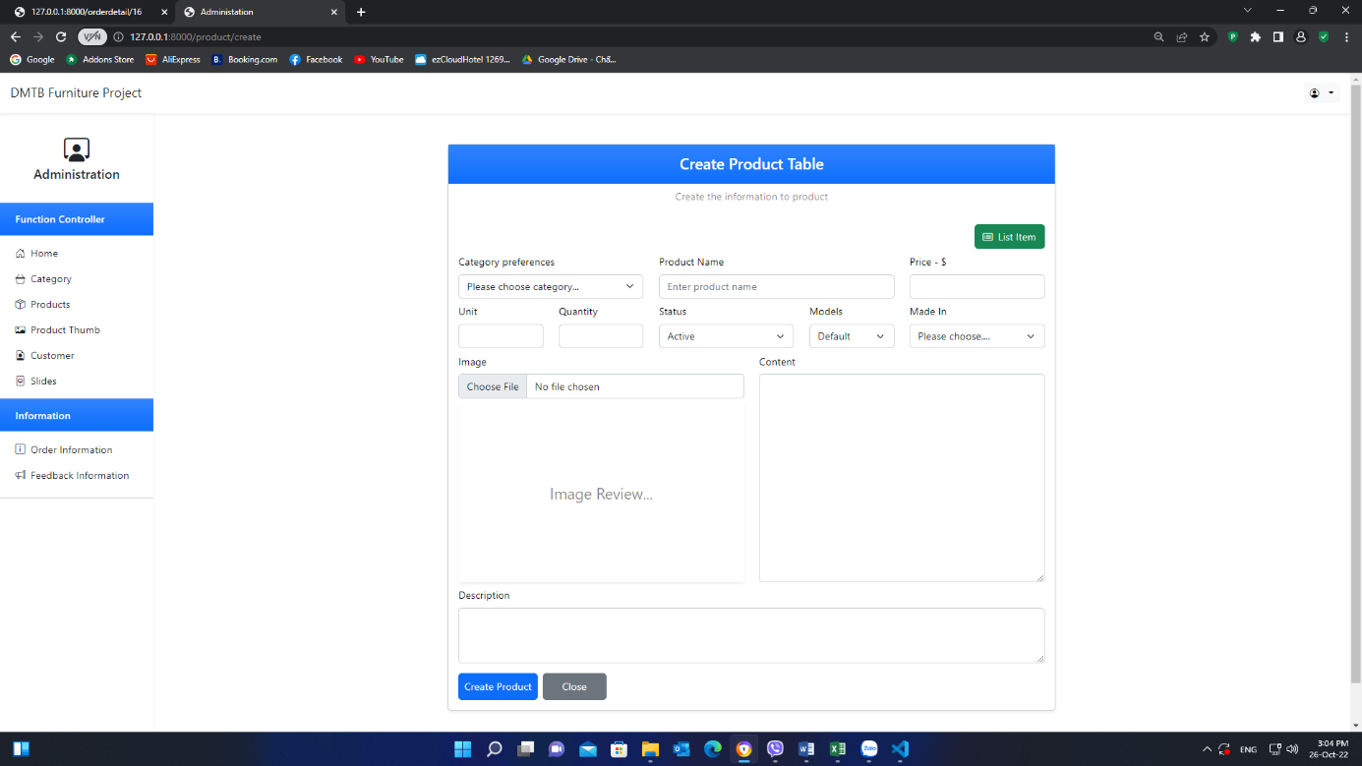

1. **Product List Page**

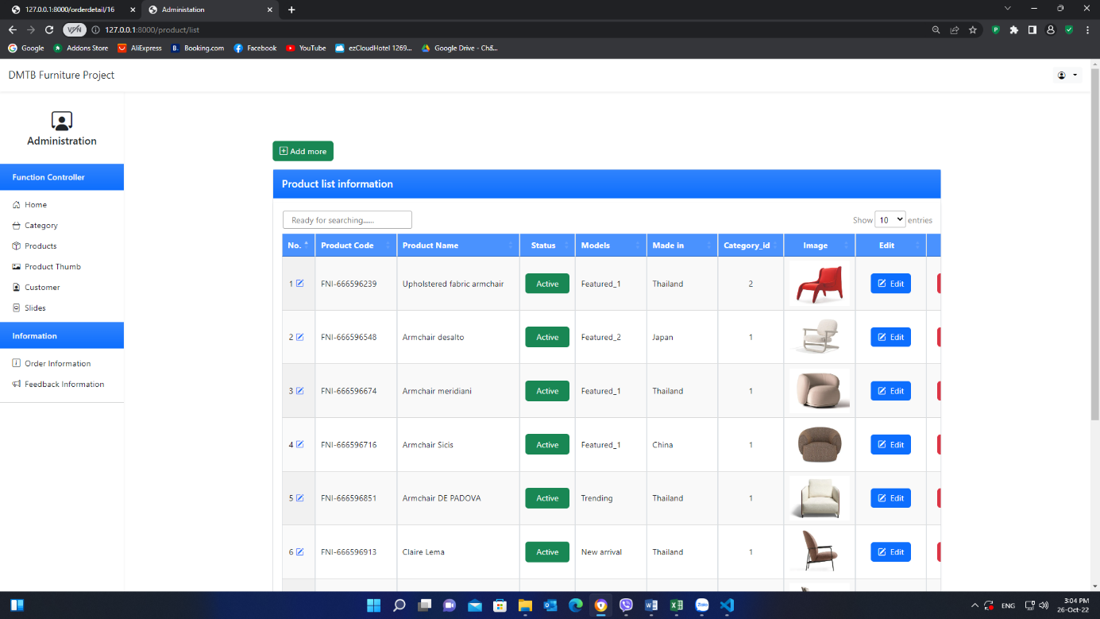

1. **Product Update Page**

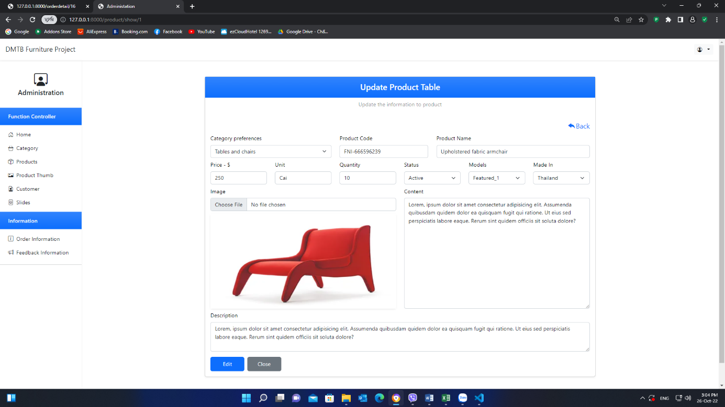

1. **Product Thumb Create Page**

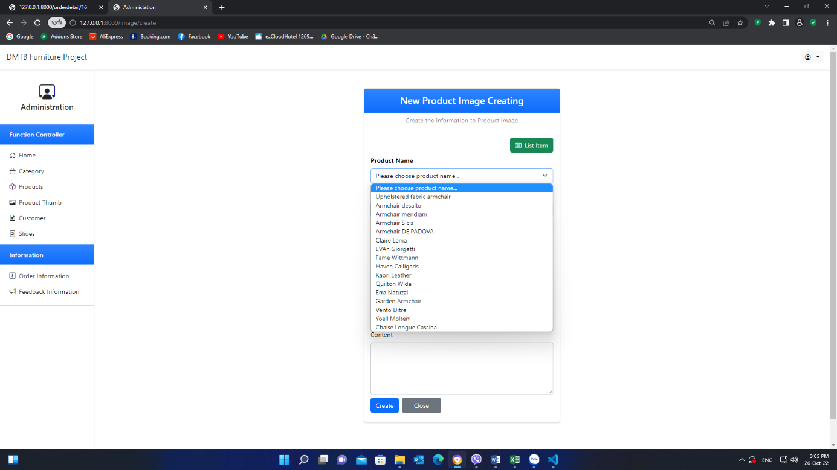

1. **Product Thumb List Page**

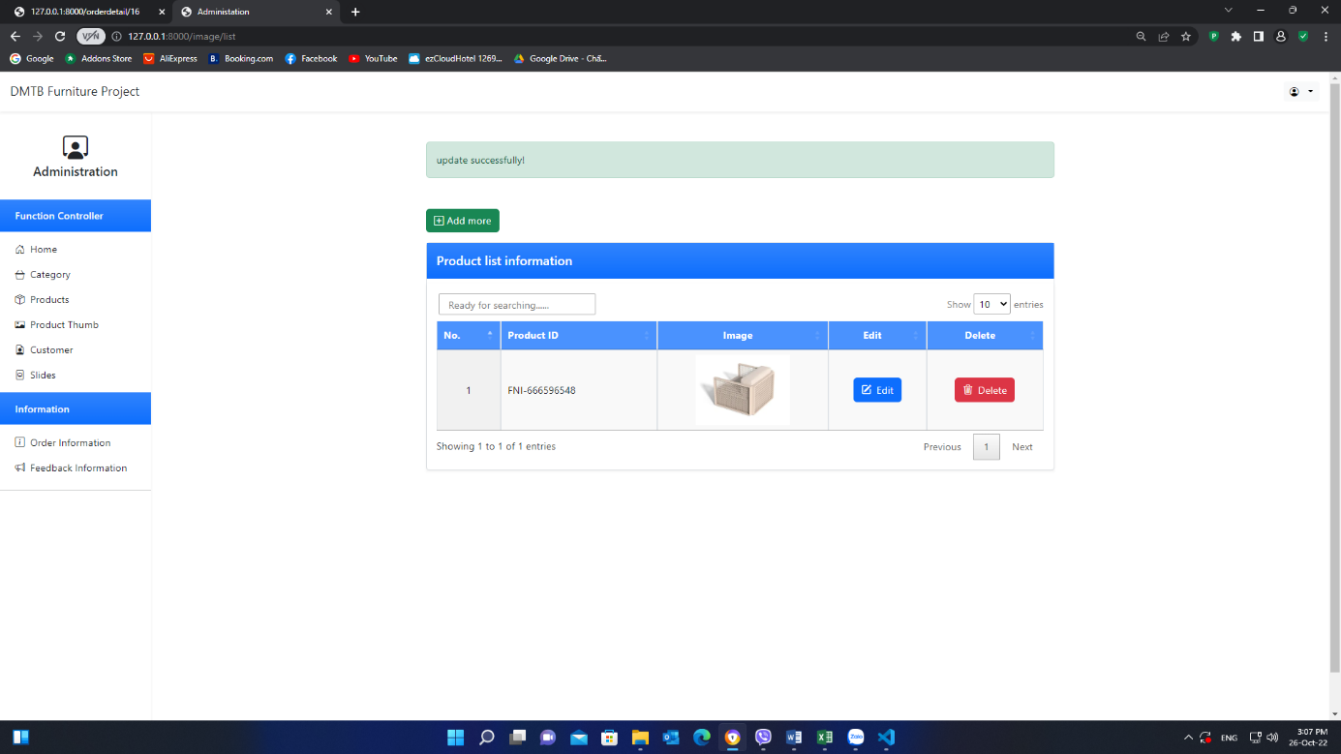

1. **Product Thumb Update Page**

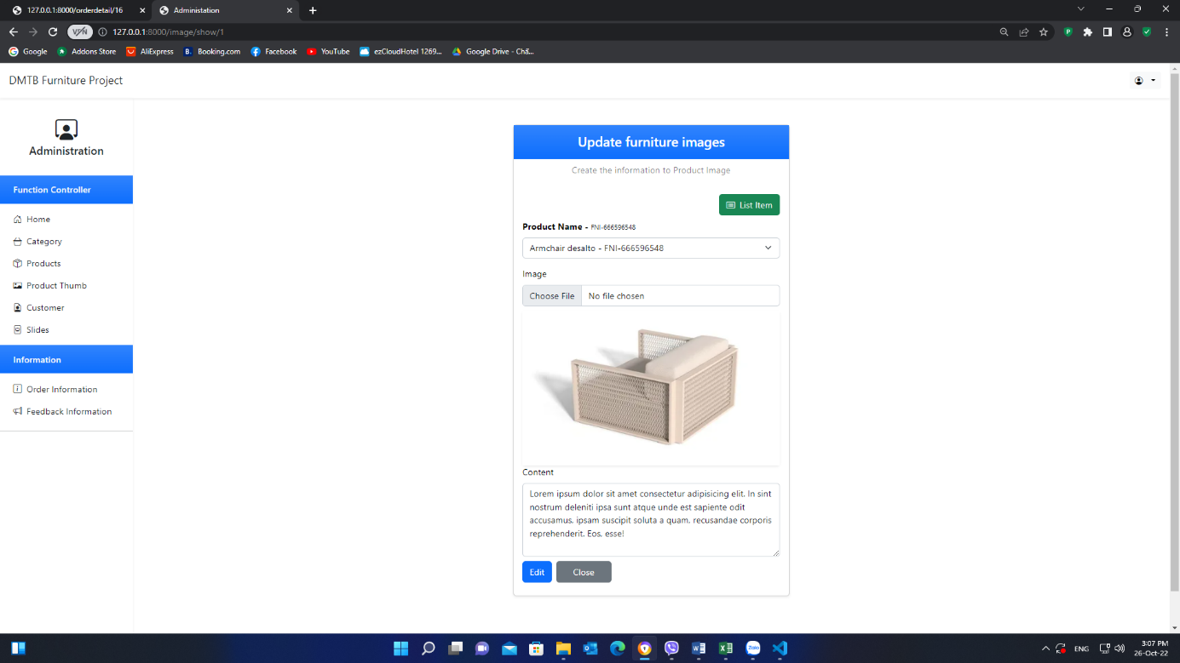

1. **Slide Create Page**

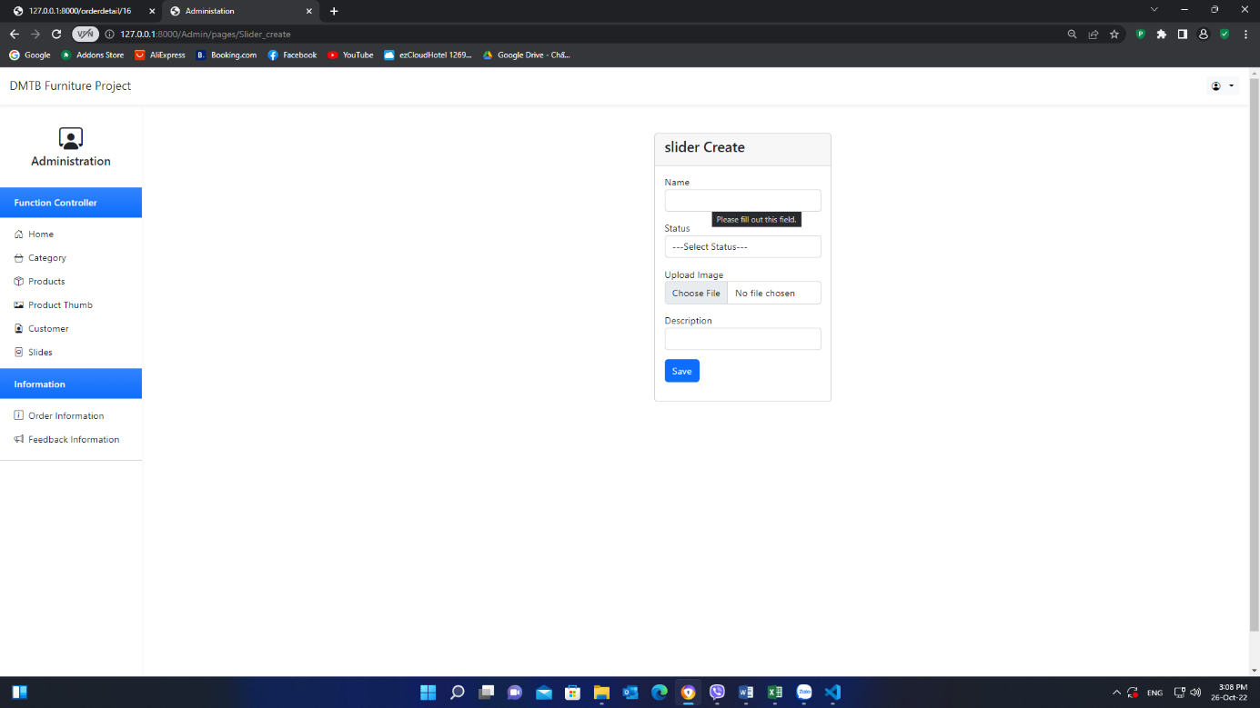

1. **Slide List Page**

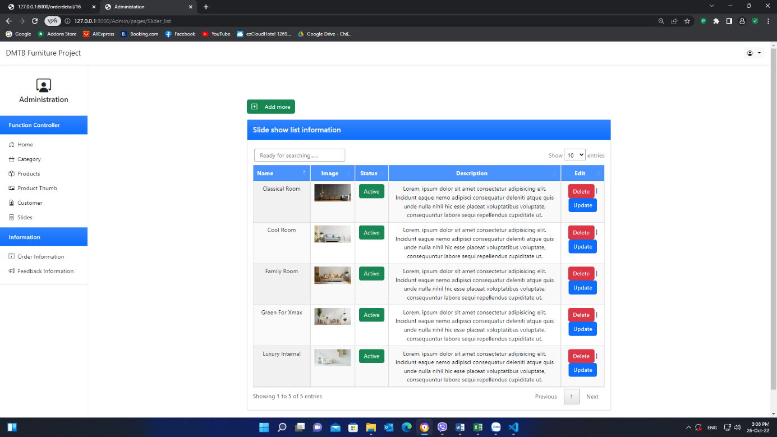

1. **Slide Update Page**

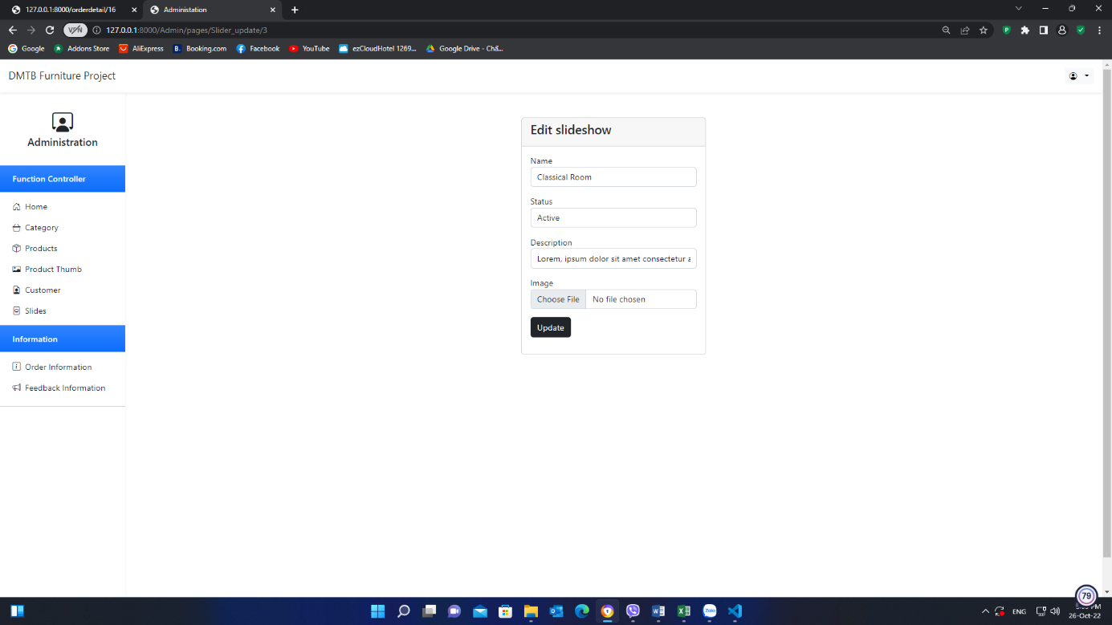

2**. User**

1. **Home page**

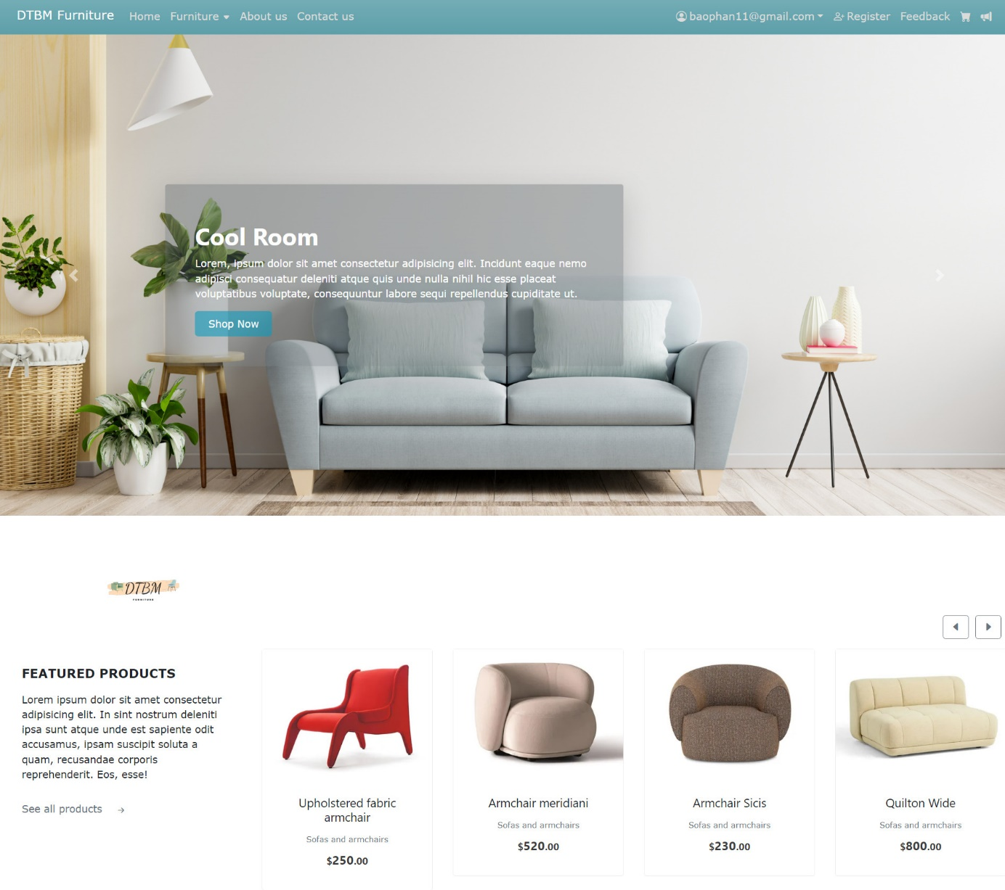

1. **Furniture Page**

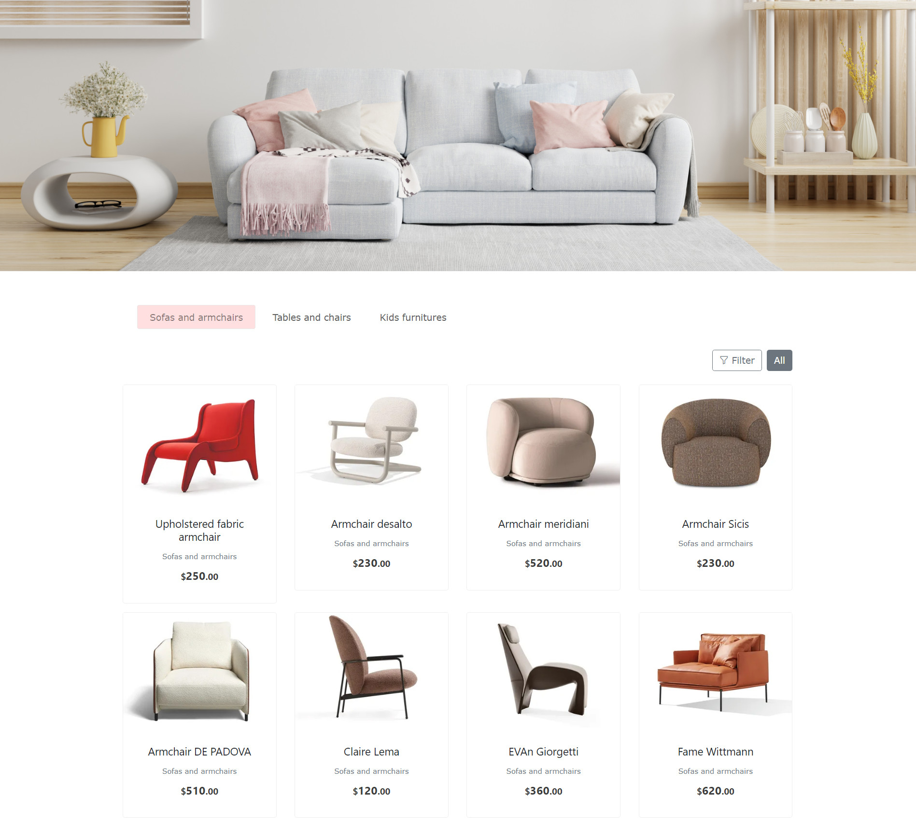

1. Contact page

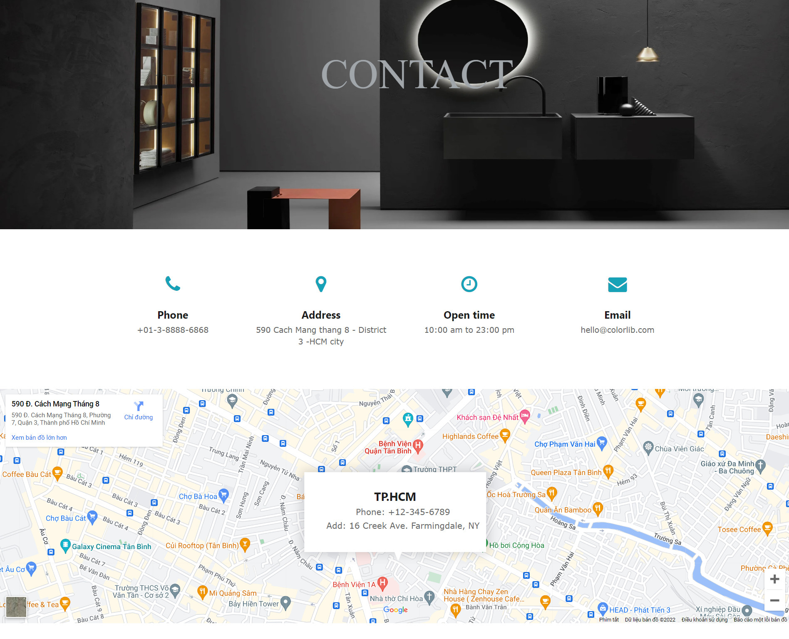

1. **Login Page**

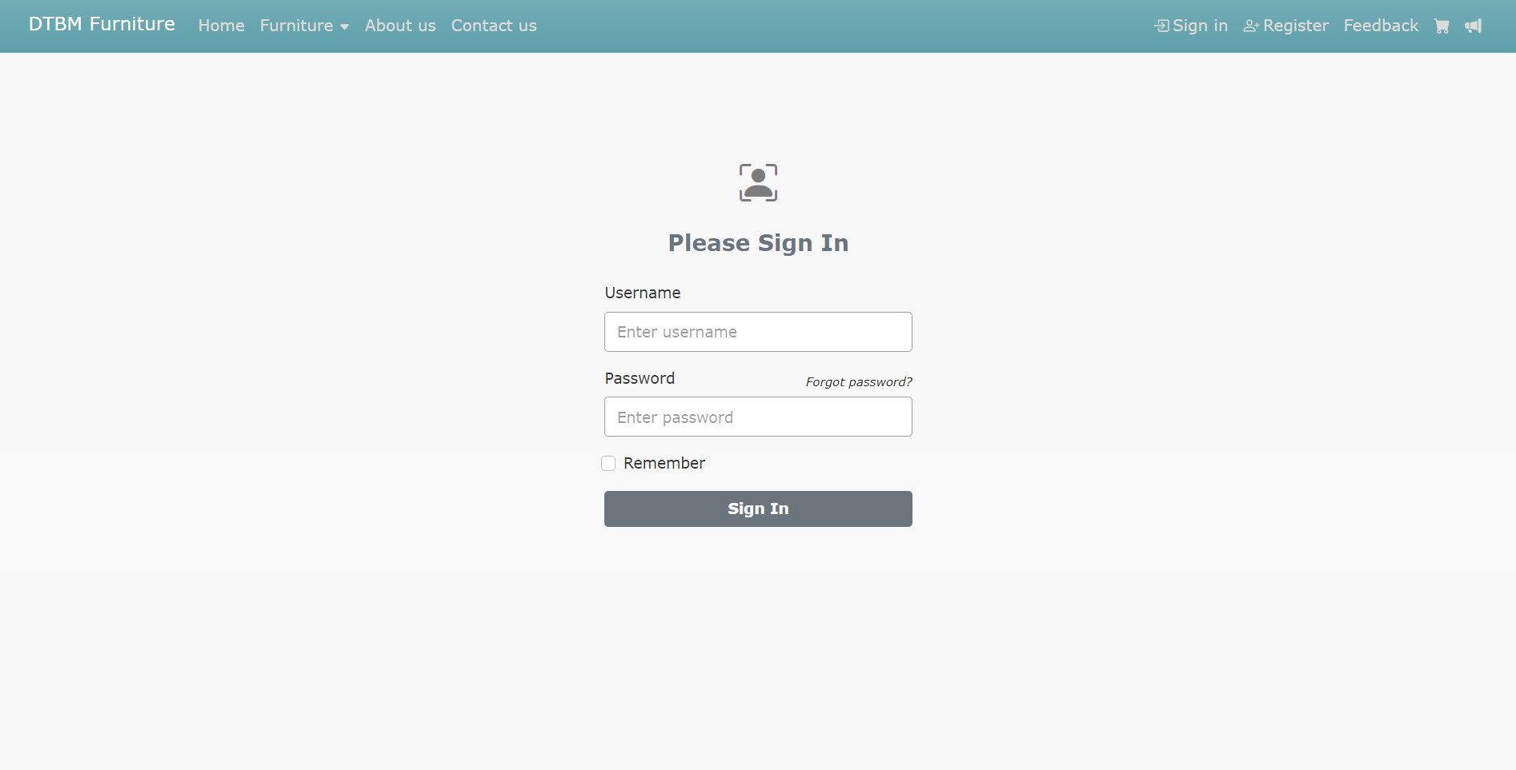

1. **Change Password Page**

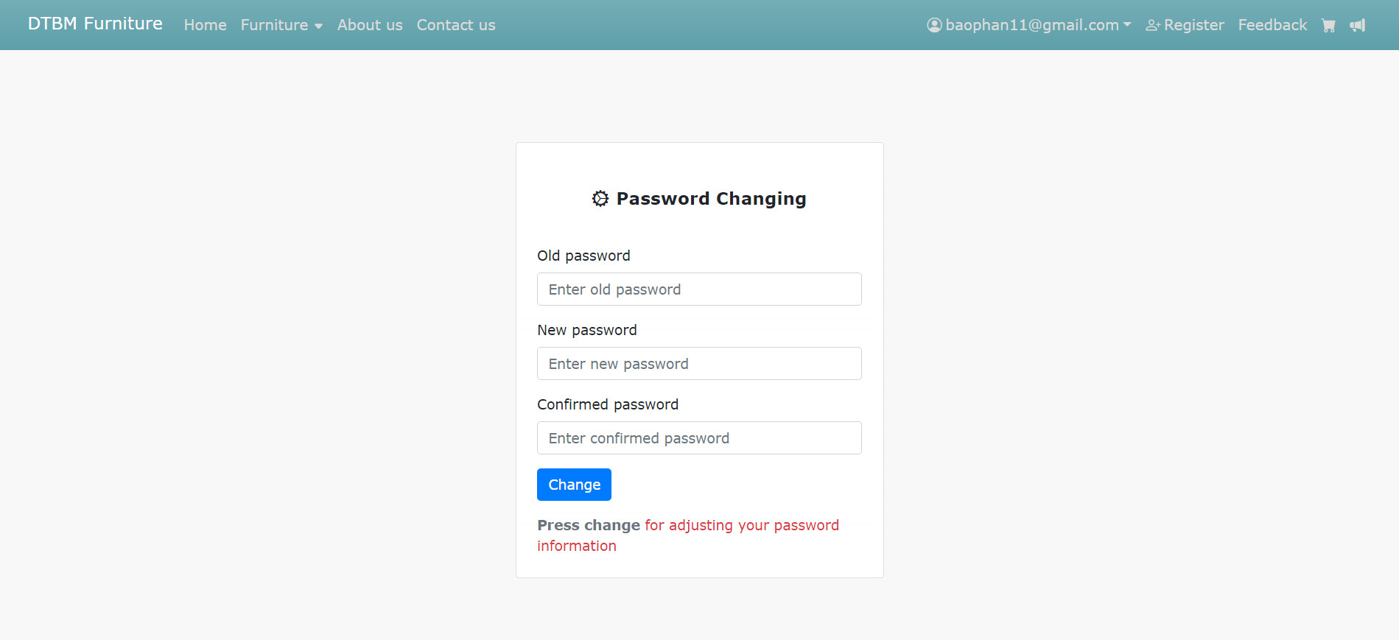

|  |
| --- |
| **Testing document** |

|  |  |  |
| --- | --- | --- |
| **Sr.No** | **Features Tested** | **Remarks** |
| 1 |  |  |
| 2 |  |  |
| 3 |  |  |
| 4 |  |  |
| 5 |  |  |
| 6 |  |  |
| 7 |  |  |
| 8 |  |  |
| 9 |  |  |
| 10 |  |  |
| 11 |  |  |
| 12 |  |  |
| 13 |  |  |
| 14 |  |  |
| 15 |  |  |

|  |
| --- |
| **Final checklist** |

|  |  |  |
| --- | --- | --- |
| **Sr.No** | **Aspected Tested** | **Suggestion/**  **Remarks** |
| 1 | Are all the users able to view the images and links? |  |
| 2 | Have all the views, modules and controllers been properly integrated and is the site function as a single page application? |  |
| 3 | Are the GUI content devoid of spelling mistakes? |  |
| 4 | Is the application user-friendly? |  |
| 5 | Is the Website launching correctly in all popular browsers? |  |
| 6 | Are all the forms validated with proper criteria? |  |
| 7 | Do all text links lead to the appropriate website? |  |
| 8 | Do all image links lead to the appropriate website? |  |
| 9 | Are all the images and links clearly visible on the page? |  |
| 10 | Does the Web page work properly in all the tested browsers? |  |
| 11 | Does the Web page take too long to be loaded fully? |  |
| 12 | Is the navigation sequences correct through all the Web pages on the site? |  |
| 13 | Is the JavaScript code working as expected in all click events? |  |
|  |  |  |
|  | (Sinh viên ghi thêm…) |  |

|  |  |  |  |  |  |  |  |  |
| --- | --- | --- | --- | --- | --- | --- | --- | --- |
| **No** | **Member** | **Contents** | | **Table Name** | **Activity Plan** | **Date of Preparation of Activity Plan** | | |
| **Planed Start Date** | **Actual Start**  **Date** | **Actual**  **Days** | **Status** |
| 1 | **Phạm Anh Đoàn** | Admin | *\* Category, product's image Management.*  *\* Account management*  *\* Function: View/add/edit/delete/search* | Account | 10/12/2022 | 10/12/2022 | 5 |  |
| 2 | Category | 10/12/2022 | 10/12/2022 | 2 |  |
| 3 | User | *\* Function: Register, view, search, add* | Product's image | 10/12/2022 | 10/17/2022 | 3 |  |
|  |  |  |  |  |  |  |  |  |
| 1 | **Khương Xuân Thanh** | Admin | *\* Order, product Management*  *\* Function: View/add/edit/delete/search* | Order_master | 10/12/2022 | 10/14/2022 | 3 |  |
| 2 | 3 |  |
| 3 | User | *\* View, approve and search order detail of customer* | Orderdetail | 10/12/2022 | 10/15/2022 | 4 |  |
|  |  |  |  |  |  |  |  |  |
| 1 | **Phan Như Bảo** | Admin | *\* Contact, feedback and slide management*  *\* Function: Add/edit/delete/search* | Contact | 10/12/2022 | 10/12/2022 | 3 |  |
| 2 | Feedback | 10/12/2022 | 10/14/2022 | 3 |  |
| 3 | User | *\* View and search* | Slide | 10/12/2022 | 10/15/2022 | 4 |  |
|  |  |  |  |  |  |  |  |  |
| 1 | **Trần Nhật Minh** | Admin | *\* About and customer Management*  *\* Function: View/add/edit/delete/search* | About | 10/12/2022 | 10/14/2022 | 3 |  |
| 2 | User | *\* View and search* | Customer | 10/12/2022 | 10/16/2022 | 3 |  |